API Tester Agent — Architecture
Oct 29, 2026 · @Kuldeep bisen
The API Tester Agent is a GitHub Copilot custom agent that turns an API description into reviewed, framework-native tests in any team's repo. It uses two shared Markdown files plus one profile per repo, and it reports every change it makes in Copilot Chat.

Components
The workflow lives in one file, framework knowledge in a second, and each repo's conventions in a third that the agent generates. Only the first two are shared across teams.
File | Owner | Holds | Changes per team?
.github/agents/api-tester.agent.md | QA platform owner | Behaviour rules, the 7-step workflow (Step 0–6), scenario catalog, report format, guardrails | No
.github/skills/api-test-adapters/SKILL.md | QA platform owner | Framework detection rules, profile template, one adapter per framework style | No; new adapters are added centrally
.github/api-testing-profile.md | Generated by the agent, confirmed by the team | Style, run commands, paths, base class, request spec, auth helper, config source, reference test, team rules | Yes, one per repo
The agent file says what to do; the adapter says how to write it for a given framework; the profile says where and in whose style for this repo.

Architecture at a glance
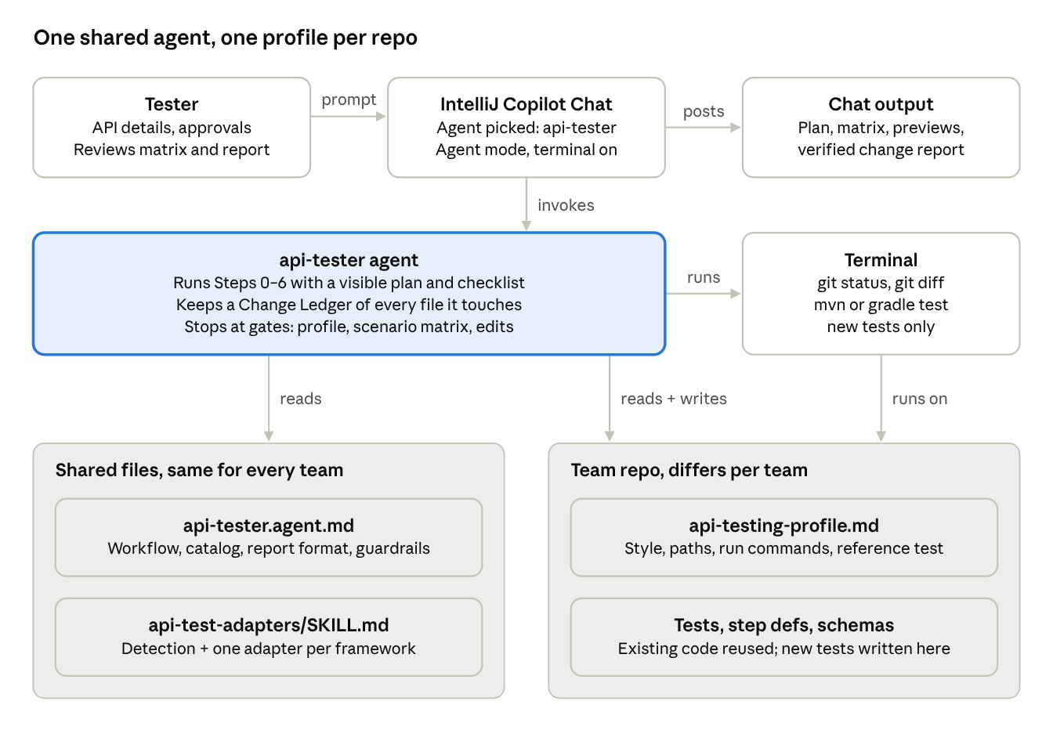
architecture · chat, agent, terminal, shared files, team repo
The tester only talks to Copilot Chat. The agent reads the shared files, reads and writes the team repo, and uses the terminal for git and the test run. Everything comes back as chat output.

What happens when a tester sends a prompt
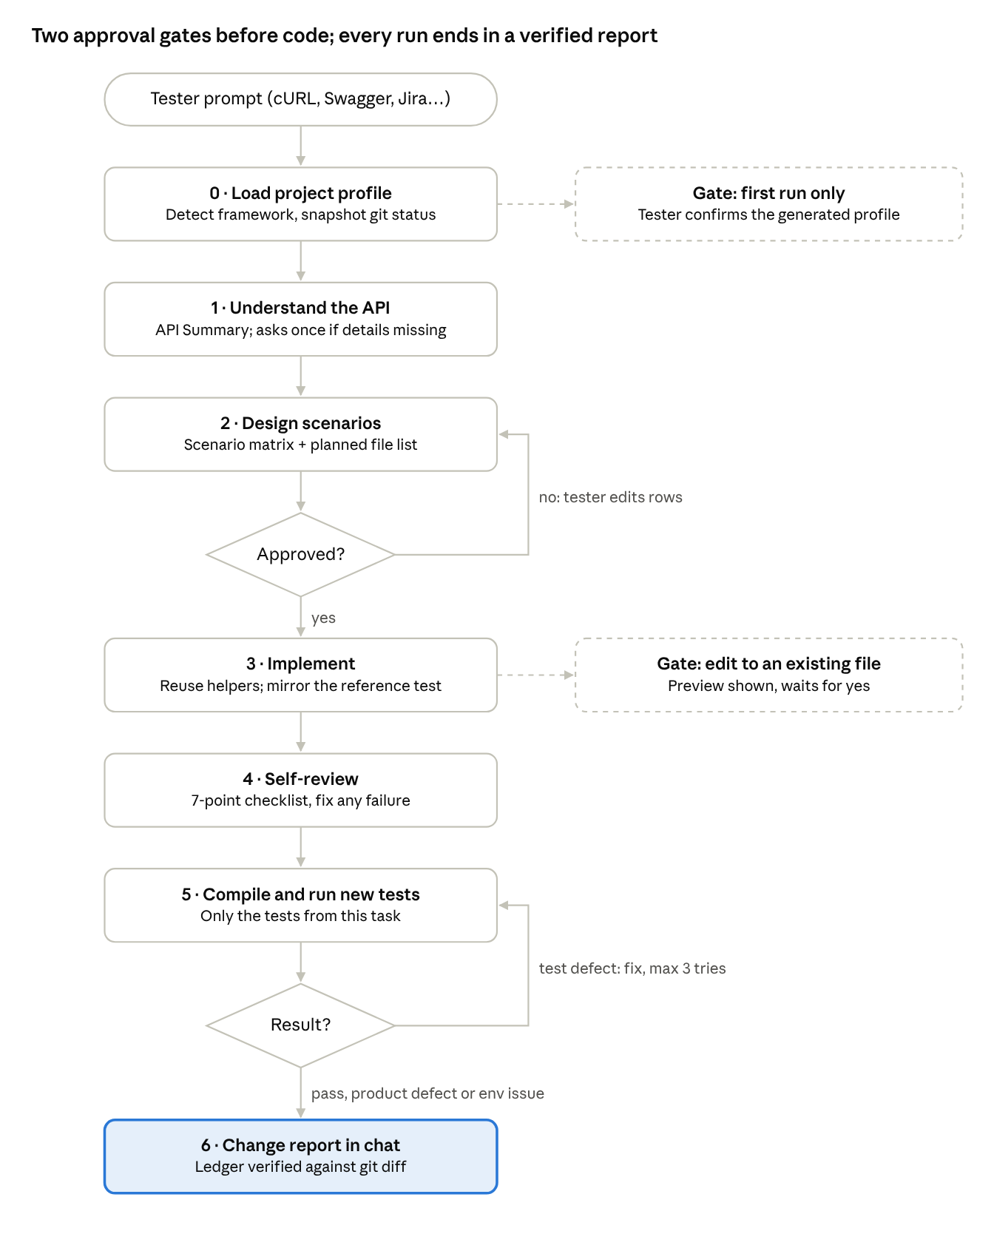
prompt-to-report flow · 7 steps, 2 decisions, 2 gates
No code is written until the scenario matrix is approved, and no existing file is changed without a preview. Only test defects loop back. Product defects and environment issues go straight to the report.

Step-by-step: what happens inside
Each step reads specific inputs, produces a visible output in chat, and only Steps 0, 3 and 5 write to the repo.
Step | What the agent does | Reads | Writes / shows | Waits for tester?
Plan | Posts a 7-item checklist and ticks it off with one status line per step | — | Checklist in chat | No
0. Load profile | Snapshots git status (files already dirty); loads or generates the profile; loads the matching adapter; opens the reference test | Profile, adapter skill, pom.xml / build.gradle, existing tests | Profile file (first run only), detection summary with evidence | Yes, first run only (confirm profile)
1. Understand the API | Parses cURL / OpenAPI / Postman / Jira / plain text into an API Summary; checks for existing tests on the endpoint | Tester input, existing test code | API Summary table, batched questions, assumptions | Only if essentials are missing
2. Design scenarios | Builds the scenario matrix from the catalog and the file plan (NEW / MODIFY / REUSE) | API Summary, profile | Scenario matrix with IDs API_<Name>_<TYPE>_<NN>, file plan | Yes, approval gate
3. Implement | Reuses clients, specs, steps; mirrors the reference test; data-drives negatives; previews every edit to an existing file | Adapter rules, reference test, existing helpers | Test classes / features, step defs, POJOs, schemas; one line per file | Yes, for each edit to an existing file (or "approve all")
4. Self-review | Runs a 7-point checklist on its own code and fixes any failure | Generated code | Checklist result in chat | No
5. Run & triage | Compiles, runs only the new tests, classifies failures, fixes test defects (max 3 tries) | Profile run commands, test output | Fixes recorded in the ledger | No (stops on environment issues)
6. Report | Verifies the ledger against git status / git diff --stat, then posts the change report | Ledger, git, run output | Full report in chat | No

Framework detection and adapters
One agent serves every team because it detects the framework from the build file and switches adapter, never the workflow. The first matching rule wins.
Evidence in build file | Style chosen | Key adapter rules
Serenity + serenity-screenplay-rest | serenity-screenplay | Tasks for calls, Questions for reads, CallAnApi ability from config
Serenity + Cucumber | serenity-cucumber | SerenityRest, @Step libraries, base URL from serenity.conf
Serenity, no Cucumber | serenity-junit | As above, JUnit runner
Cucumber + REST Assured | cucumber-restassured | Reuse existing steps first; generic parameterised steps; Scenario Outline for negatives; run by tag
REST Assured + TestNG | restassured-testng | <Resource><Operation>ApiTest, DataProvider, groups + description carry the scenario ID
REST Assured + JUnit | restassured-junit | @ParameterizedTest, @Tag, @DisplayName with the scenario ID
Karate | Not supported yet | Agent tells the tester and stops
If two styles exist in one repo, the agent asks which one new tests should follow. To support a new framework, add one detection rule and one adapter section to the skill file; the agent file does not change.

Change tracking and the chat report
Every file the agent touches is recorded in a Change Ledger and checked against git before the report is posted, so the report cannot list a file that wasn't changed or miss one that was.
- Baseline: in Step 0 the agent runs git status --porcelain and remembers files that were already dirty.
- Ledger: every create, modify or delete is recorded with its reason as it happens, including fixes made during triage.
- Verification: in Step 6 it runs git status --porcelain and git diff --stat, removes the baseline files, and reconciles both lists before posting.
- Evidence: pass/fail counts are quoted from the actual run output; anything not run is reported as "not run".
The report posted in Copilot Chat has these sections:
Section | Content | Always shown?
Header | API, framework style, Jira key, pass / fail / skip counts | Yes
Files changed | Table: action, path, what changed, why | Yes
Changes to existing files | Diff of only the agent's own edits | When an existing file was modified
Scenario traceability | Scenario ID → file and test → result | Yes
Possible product defects | Request, expected, actual | When any
Assumptions & decisions | Everything assumed in Step 1 | When any
Skipped / not covered | Scenarios not implemented and why | When any
Observations | Unrelated issues noticed but not fixed | When any
Run it yourself | Exact command and report path | Yes
Undo these changes | git checkout / git clean -n commands | Yes
Blocked | Why the task stopped early | When stopped early

Guardrails and failure triage
The agent never weakens an assertion to get a green run; a failing test is sorted into one of three kinds and handled differently.
Failure kind | Example | Agent action
Test defect | Wrong path, wrong payload, compile error, wrong framework assumption | Fix and re-run, max 3 attempts per test, each fix in the ledger
Possible product defect | API returns 500 where the story says 400 | Leave the test failing, report request / expected / actual
Environment issue | Connection refused, dependency 5xx, auth server down | Stop and report; no test edits
Guardrails that always apply:
- No hardcoded URLs, tokens, passwords or API keys; config comes from the framework's own mechanism.
- Never runs against production; stops and asks if the environment looks like production.
- No edits to framework core, build files or config without explicit approval.
- No new framework, runner or assertion library.
- No commit, push or branch creation unless asked; changes stay in the working tree for review.
- Never deletes or rewrites tests it did not create in the current task.
- Stays in scope; unrelated problems go under Observations.

Rollout and extension
Start with one pilot repo and 3–5 real APIs, then publish centrally once the adapter rules stop needing changes.
- Pilot: copy the two shared files into one repo, select the api-tester agent in IntelliJ Copilot Chat, and give it a cURL or Swagger snippet.
- Confirm the profile: check the generated api-testing-profile.md, correct it, commit it.
- Tune: review the matrix and generated code; tighten adapter rules wherever output didn't match team standards.
- Measure: scenarios generated, tests compiling first time, reviewer rejections, time per API.
- Distribute: org or enterprise level through a .github-private repository, or copy the two files into each team's repo.
The agent also learns per repo: when a tester corrects a convention, it offers to save it under Team rules in the profile, and only writes it after a yes.

Open questions to confirm in the pilot
- ☐ Does the IntelliJ Copilot plugin version in use support custom agents (public preview for JetBrains IDEs)?
- ☐ Does it load skills from .github/skills/? If not, the agent already reads the adapter by path in Step 0.
- ☐ Is agent mode allowed to run terminal commands (git, mvn)? If not, run results and git verification are reported as "not run".
- ☐ Which input do testers use most: OpenAPI, cURL, Postman or Jira?
- ☐ Which framework style does the pilot team use?

